PROJECT DOCUMENT

- Project Title: Garage management system

- College Name: Annamacharya Institute of Technology and Science

TEAM
  - Team ID: LTVIP2025TMID29039
  - Team Size: 4

  - Team Leader: G.Navitha
  - Team member: D.Tejavardhini
  - Team member: C.Sarika
  - Team member: S.Anjali

MAIL IDs:
gnavitha555@gmail.com
tejavardhini3547@gmail.com
sarika.cv3@gmail.com
anjalisagabala000@gmail.com

Project Overview: Garage management system
- Objective :

This project is to develop a robust digital platform for an automotive service outlet that streamlines scheduling, work orders, inventory, billing, staff coordination, and customer engagement. The system ensures data integrity, supports real-time operations, and delivers actionable business insights.If you're planning to build this on Salesforce, key custom objects might include Vehicle, Booking/Appointment, Job Order, Inventory Item, Parts Usage, Customer, and Invoice. Workflow automation (Flows) would enforce rules such as resource availability, parts stock checks, and notification triggers. User roles and page layouts would secure data access per function (e.g. mechanic view vs admin view).
IDEATION PHASE
The Ideation Phase establishes the conceptual groundwork of the Garage Management System. It combines user-centric research, creative problem-solving, and structured refinement to uncover the core needs of stakeholders—such as garage owners, technicians, service advisors, parts vendors, and customers—and define high-value features to address vehicle service challenges.
As our project titled: “GARAGE MANAGEMENT SYSTEM’’ the Xplanning efficiency to build this on Salesforce, key custom objects might include Vehicle, Booking/Appointment, Job Order, Inventory Item, Parts Usage, Customer, and Invoice. Workflow automation (Flows) would enforce rules such as resource availability, parts stock checks, and notification triggers. User roles and page layouts would secure data access per function
- Brainstorming & Idea Prioritization Template
Step 1: Team Gathering, Collaboration, and Selecting the
Problem Statement ;
Goal: Identify inefficiencies in the garage’s current operations (e.g. scheduling conflicts, inventory gaps, communication delays)
Participants: Garage owner/manager, service advisors, technicians, customer representative, and vendor/logistics rep.
Activity: Use digital whiteboards or sticky notes for mapping existing workflows such as
- Bay or technician scheduling
- Customer service and inquiries
- Parts/spare inventory control
- Job assignments and status tracking
- Payment processing and invoicing
After several discussions and stakeholder reviews, we clearly articulated the core issue:
Problem Statement:
“Garage operations are hampered by fragmented, manual processes across booking, job tracking, parts inventory, customer communication, and billing. Without a centralized, digital platform, technicians and service advisors face scheduling conflicts, delays due to missing parts, billing inaccuracies, and poor visibility into business metrics—leading to inefficiency, revenue leakage, and reduced customer trust.”
This statement became the cornerstone of our project scope and set the direction for developing a tailored,powered platform that would streamline operations and elevate the customer experience.
Step 2: Brainstorm, Idea Listing, and Grouping
We conducted a collaborative brainstorming session via a digital whiteboard where each team member contributed fresh ideas drawn from user interviews, industry research, and operational needs. We then clustered these ideas into major functional themes, reflecting high-impact priorities for a Garage Management System.
- Appointment Scheduling & Booking : Centralized calendar to visualize bay & technician availability.Live conflict detection and auto-blocking of overlapping slots.
- Job Order & Workflow Automation : Auto-generated job cards linking customer, vehicle, and service details.Workflow status tracking: inspection → repair → QA → completion.
- Inventory & Parts ManagementReal-time tracking of stock levels; auto-reorder triggers at thresholds.Link parts consumption directly to job orders and billing.
- Customer Relationship Management & CommunicationRich client profiles with service history and preferences.Automated notifications via SMS/WhatsApp/email for updates, maintenance reminders, promotion

From a pool of 25–30 ideas, we clustered and shortlisted those that directly improved efficiency, reduced manual work, and elevated the customer experience. These formed the foundation for our product roadmap.
Step 3: Idea Prioritization
These are “Must-have” features that align with feasibility, high operational impact, and urgent need:
- Real-time booking & conflict prevention
Implement live technician and bay scheduling with conflict alerts and sync integration (e.g., Google Calendar) to avoid double-booking.
- Customer & vehicle profile management
Store customer info and service/repair history so staff can quickly access past visits, service preferences, and pending work.
- Automated reminders and confirmations
Use SMS/email/WhatsApp to confirm bookings, notify customers about upcoming appointments or ready vehicles—reduces no-shows and improves satisfaction.
- Dynamic dashboard & analytics
Visualize workforce utilization, shop capacity, revenue trends, peak hours, and performance metrics—empowers owners and managers to make data-driven decisions.
- Role-based secure access
Provide tailored access for admins, front-desk staff, mechanics, and vendors, ensuring data integrity and secure operations.

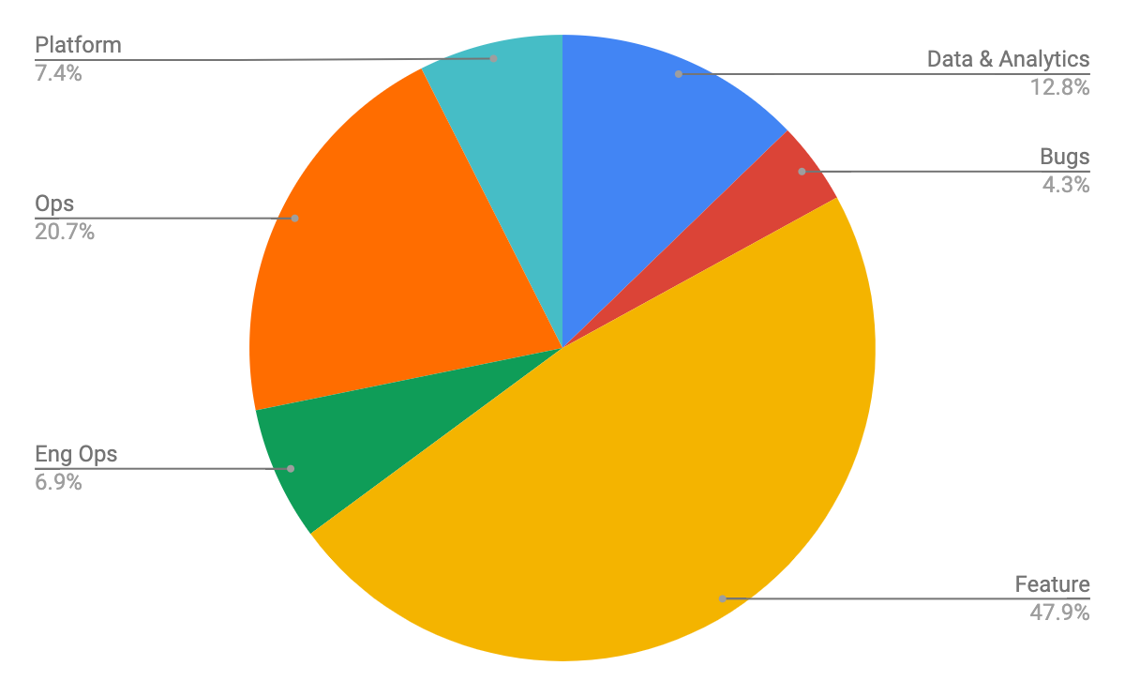x
2. Empathy Mapping- Empathize & Discover
Empathy Map Canvas
An Empathy Map helps teams visualize what users think, feel, say, and do—providing insight into their pain points, needs, and motivations. For our Garage Management System, we mapped the experiences of key stakeholders to ensure the system solves real-world problems.

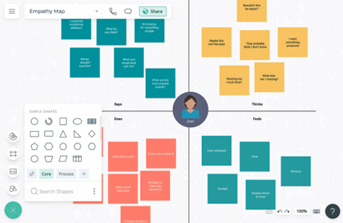

3.Define the Problem Statements
Customer Problem Statement Template
Garage owners, service advisors, and mechanics currently manage vehicle service bookings, customer communications, spare part inventories, and billing through disjointed or manual methods such as paper registers, spreadsheets, or basic software. This leads to missed appointments, delayed service updates, inventory mismatches, billing errors, and poor customer satisfaction due to lack of transparency and tracking. A centralized Garage Management System (GMS) powered by Salesforce CRM can streamline service workflows, maintain accurate customer and vehicle history, automate notifications (SMS/WhatsApp/email), track inventory and billing in real time, and generate performance dashboards. This statement aligns with the expectations of garage staff and vehicle owners and served as a guiding reference for our object models, validation rules, process automations, and analytical dashboards.

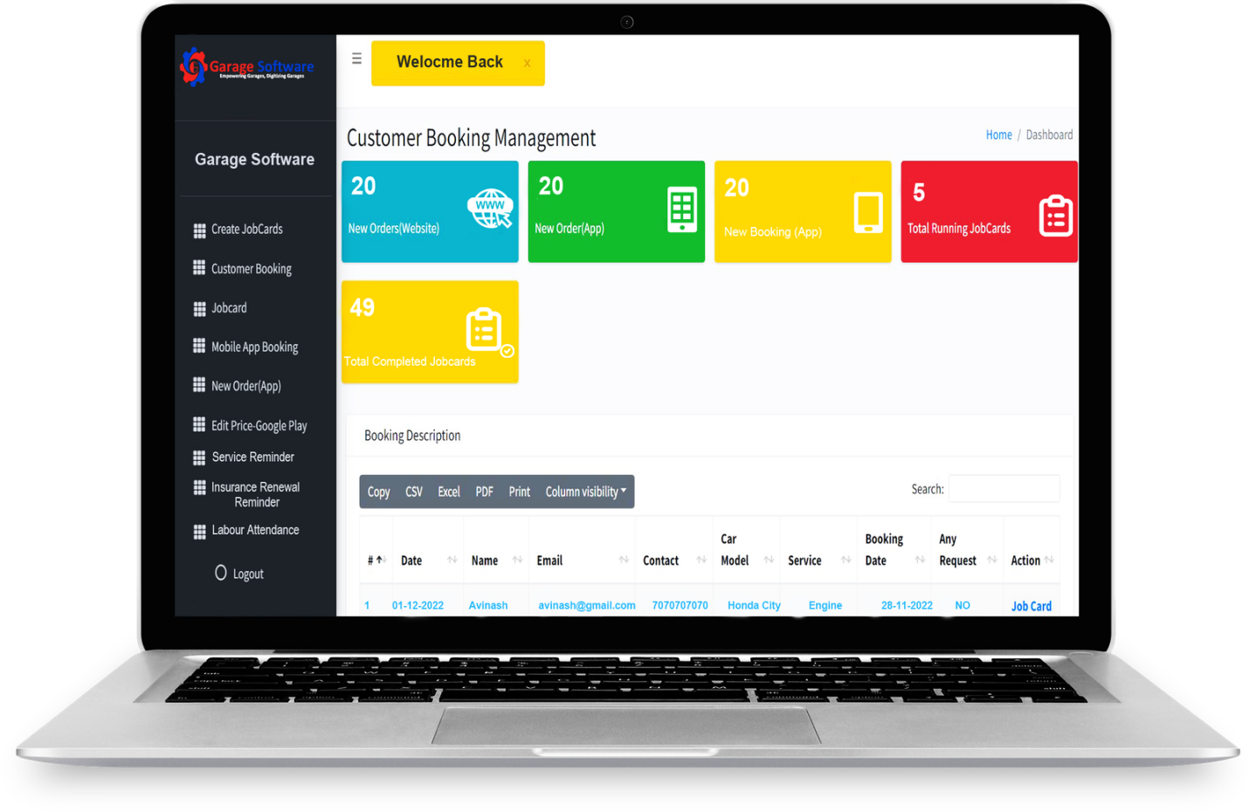
REQUIREMENT ANALYSIS
The Requirement Analysis Phase focuses on gathering, organizing, and validating all key system needs to ensure a clear and efficient development roadmap. This phase ensures that the final Garage Management System is not only technically sound but also aligns with the practical, day-to-day needs of stakeholders—such as garage owners, service advisors, mechanics, parts managers, and customers.
In our project, “A CRM-based Garage Management System,” this phase served as the critical link between identifying operational inefficiencies in traditional garage workflows and designing a smart, streamlined system. Through stakeholder interviews, service flow analysis, and functional requirement gathering
1.Customer Journey Map-Understanding User Experience Flow
Purpose: The Customer Journey Map visualizes how key stakeholders in the garage ecosystem—such as Garage Owners, Service Advisors, Mechanics, Parts Managers, and Customers—interact with the vehicle service and repair process on a daily basis. It highlights core actions, common pain points, emotional highs and lows, and potential opportunities for improvement.
This real-world perspective guides the design of the Garage Management System (GMS) to ensure it aligns smoothly with user workflows, reduces manual errors, automates repetitive tasks, and enhances the overall vehicle servicing experience.
By mapping user touchpoints such as vehicle check-in, service estimation, repair updates, spare parts procurement, billing, and feedback collection, the journey map helps identify bottlenecks like communication delays, inventory mismatches, or scheduling conflicts. Addressing these pain points through the CRM-driven GMS will improve operational efficiency, boost customer satisfaction, and support data-driven management decisions.
Journey steps:

2.Data Flow Diagram:
Purpose: Mapping Information Flow Between Objects
The Data Flow Diagram (DFD) illustrates how information moves between Salesforce objects and components in the Garage Management System. It helps structure the relationships between:
Customer, Vehicle, Service Booking, Mechanic, Spare Parts Inventory, Billing, and Payment.

- Admin & Staff Inputs:
- Create and update Customer and Vehicle profilesSchedule and update Service Bookings with details (service type, date/time)
- Assign Mechanics to service tasks
- Manage Spare Parts inventory and order new stock
- Record Billing details and payments
- System Logic:
- bleValidates service slot availability and mechanic schedules
- Checks spare parts availability before service confirmation
- Calculates service costs dynamically based on labor, parts used, and taxes
- Applies discounts or loyalty rewards where applicable
- Outputs
- Generates service status updates and notifications to customers (via SMS/email/WhatsApp)
- Produces billing invoices and payment receipts
- Displays dashboards for garage performance (e.g., service volume, revenue, inventory status)
- Triggers alerts for scheduling conflicts, low inventory, or unpaid bills.
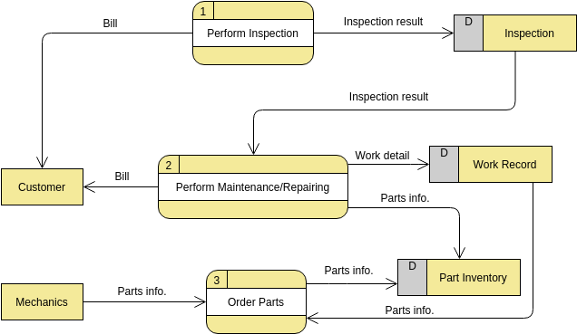

- Solution Requirements:
Functional Requirements:
- Define core Salesforce objects:
Customer: contact details, vehicle info, service history, preferences
Vehicle: make, model, registration, owner linkage
Service Booking: with date, time, service type, assigned mechanic
Mechanic: skills, availability, assigned jobs
Spare Parts: inventory, costs, reorder thresholds
Billing & Payment: methods, totals, transaction status
- Establish relationships using lookup, master-detail, and formula fields:
Service Booking → Customer, Vehicle, Mechanic
Billing → Service Booking
Spare Parts → Service Booking (used parts linked to service job)
Dynamic pricing logic via formulas (e.g., labor hours × rate + parts cost)
- Validate service booking logic using Apex Triggers:
Prevent double booking of the same mechanic or time slot
Ensure parts availability before confirming booking
Trigger alerts if service time exceeds garage capacity or mechanics are overbooked
- Automate workflows using Salesforce Flows:
Auto-confirm booking availability
Send automated notifications and reminders to customers and mechanics
Generate service checklists based on booking details
Trigger billing and payment reminders
- Support analytics through:
Dashboards showing service volume, revenue by service type, mechanic utilization
Reports for customer feedback, frequent repairs, peak service seasons
- Non-Functional Requirements:
Intuitive Lightning App interface for garage staff, managers, and customers
Real-time validation to avoid scheduling conflicts and ensure data accuracy
Centralized relational database for seamless linking of customers, vehicles, bookings, parts, and billing
Scalable system architecture to support growing garage operations and multiple branches
Secure access controls to protect sensitive customer and payment information.

- Technology Stack:

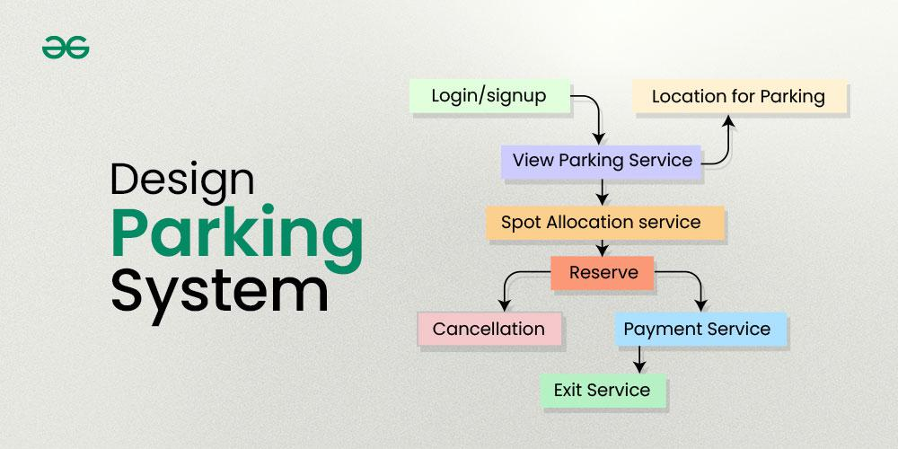
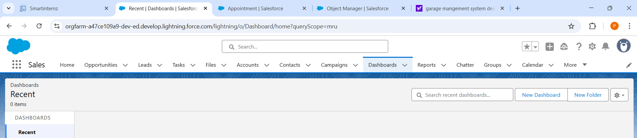

Summary:
The Requirement Analysis Phase for the CRM-based Garage Management System ensured that the solution’s features directly addressed real user challenges such as appointment overlaps, communication gaps, inventory shortages, and billing inaccuracies. This phase guided the design of well-structured Salesforce objects, validation rules, automated flows, and relational data models. It also influenced the development of an intuitive user interface and insightful dashboards, ensuring the system meets the practical needs of garage staff, mechanics, and customers. Overall, this phase laid a strong foundation for a smart, efficient, and user-focused garage management solution that enhances operational productivity and customer satisfaction.
Project Design Phase

The Project Design Phase laid the technical and functional blueprint for the Garage Management System, ensuring it directly addressed real user challenges while remaining scalable and aligned with Salesforce best practices. It translated validated pain points into structured Salesforce objects, automated flows, and business rules. This phase shaped critical decisions around data relationships, automation logic, and UI components, bridging the gap between user insights and a buildable, maintainable solution.

1. Problem–Solution Fit:
Problem Recap:
- Current garage operations rely on manual records, phone calls, and spreadsheets, causing inefficiencies
- Frequent data entry errors and duplication of customer and vehicle service information
- Lack of real-time visibility into mechanic schedules, service bookings, and parts inventory
- Poor coordination in assigning mechanics and managing spare parts, resulting in service delays.
- Challenges in tracking billing, payments, and generating service performance reports.
- Garage management requires seamless real-time coordination across customers, vehicles, bookings, mechanics, parts, and billing.
Does the Proposed Solution Fit?
Yes. The Salesforce CRM-based Garage Management System:
Introduces object-level control for Customers, Vehicles, Service Bookings, Mechanics,
- Automates availability checks, parts validation, and pricing calculations through Salesforce Flows.
- Validates mechanic assignments and booking conflicts using Apex Triggers.
- Summarizes operational and financial performance using Reports and Dashboards.
- Uses formula fields to dynamically calculate labor costs, parts charges, and total billing.
- Provides centralized scheduling, parts inventory tracking, and service status views using Lightning App Builder.
- Thus, it directly addresses the operational pain points of managing garage services and workflows in a unified, scalable, and efficient manner.
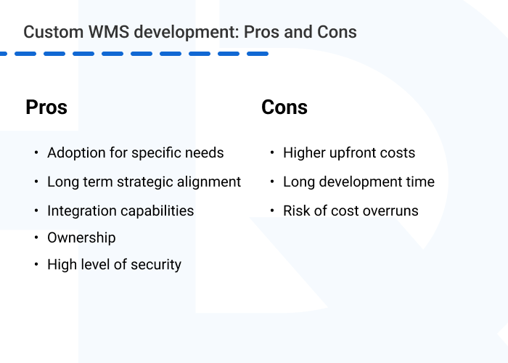

2. Proposed Solution:

Proposed Solution :
Our proposed CRM application is designed to digitize and streamline garage management operations using Salesforce’s powerful customization capabilities.

Key Functional Features:
- Custom Objects:
Customer, Vehicle, Service Booking, Mechanic, Spare Parts, Billing, Payment
- Automation & Validation:
Mechanic assignment checks to avoid double booking using Apex Triggers
Automated service cost calculation using Flows based on labor hours and parts used
Input validation for booking conflicts, missing vehicle/service details, or inventory shortages
- Formula Fields for Efficiency:
Service Duration = Service End Time – Start Time
Total Service Cost = (Labor Hours × Labor Rate) + Parts Cost – Discounts
Auto-lookup of assigned Mechanic names and Customer contact info
- UI & Navigation:
Garage Management App built using Lightning App Builder
Tabs for each custom object with user-tailored page layouts for service advisors, mechanics, and managers

- Reports and Dashboards:
Service Summary Reports by date, vehicle type, or customer
Mechanic Assignment Dashboards showing workload and availability
Monthly Revenue and Parts Usage Tracking Dashboards

3. Solution Architecture:
Object Relationship Overview
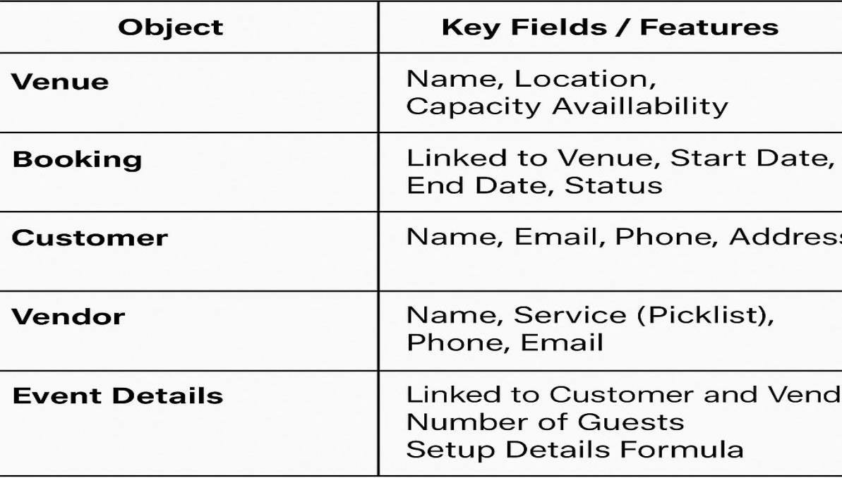

Lookups:
Staff Member → Garage Branch
Service Booking → Customer, Vehicle, Mechanic, Service Package
Service Package → Spare Parts, Labor Details
Billing → Service Booking

Formulas:
Used to auto-calculate service costs based on selected customer preferences, vehicle type, labor hours, and parts usage.
plaintext
CopyEdit
// Add-on services selected by customer
IF( Customer__r.Engine_Scan__c = TRUE, 1000, 0 )
IF( Customer__r.Car_Wash__c = TRUE, 500, 0 )
IF( Customer__r.Wheel_Alignment__c = TRUE, 1500, 0 )
IF( Customer__r.Inspection__c = TRUE, 700, 0 )
IF( Customer__r.Pickup_Service__c = TRUE, 300, 0 )

// Example CASE formula for oil change package pricing
CASE( Vehicle__r.Oil_Type__c,
'Synthetic', 3000,
'Semi-Synthetic', 2000,
'Mineral', 1200,
0
)

// Total Service Cost formula (simplified)
Total_Cost__c = (Labor_Hours__c * Labor_Rate__c) + Parts_Cost__c + Add_Ons__c - Discount__c
Automation:
- Flows for service pricing logic
- Triggers for vendor assignment validation
- Reports & dashboards for operational insights

Summary:
The Project Design Phase ensured that our banquet hall CRM solution aligned closely with the needs of customers, staff, and managers while adhering to Salesforce best practices in object modeling, validation, automation, and UI design. It provided a structured foundation for booking workflows, vendor coordination, and event cost logic. This comprehensive design blueprint served as a critical guide for the upcoming build and configuration stages, ensuring clarity and scalability.

Project Planning Phase
The Project Planning Phase translated key functional goals of the Garage Management System into structured, time-bound development sprints. This ensured clear task ownership, effective team collaboration, and continuous progress tracking throughout the CRM implementation lifecycle.
By breaking down complex features—such as service booking automation, mechanic assignment logic, inventory integration, billing workflows, and dashboard reporting—into manageable deliverables, the project team could stay aligned with stakeholder expectations while maintaining agility in execution.
Each sprint focused on a distinct module (e.g., Customer & Vehicle Management, Service Booking, Payment Integration), with built-in checkpoints for validation, feedback, and iteration. This phase helped set realistic timelines, resource allocation, and deployment priorities, ultimately enabling a smooth rollout of a scalable and user-centric garage management solution.
Project Planning Template
Sprint Schedule – Based on Project Milestones
Sprint | Functional  Requirement  (Epic) | T ask (Mapped from  Milestone) | Priority | Team Members
Sprint-1 | Developer  Setup & Basic  Objects | Creating Developer  Account & Activating  Org | High | Member 1
Sprint-1 | Custom Object  Creation | Creating custom  Objects-A Banquet  booking application | High | Member 1,2
Sprint-2 | UI Tabs & App  Creation | Creating Tabs &  Lightning App | High | Member 3
Sprint-2 | Field  Configuration | Creating fields,  formula fields,  picklists, relationships | Medium | Member 1,3
Sprint-3 | Layouts &  Validations | Page Layouts +  Validation Rules | High | Member 2,4
Sprint-3 | Flows &  Triggers | Automations using  Flows and Apex  Triggers | High | Member 2,3
Sprint-4 | Reports &  Dashboards | Generate Reports and  create Dashboards | High | Member 4
Sprint-4 | Final  Integration &  Conclusion | Final Review, Testing,  and Functional  Summary | Medium | All Members

Project Tracker & Sprint Timeline
Duration: Each sprint is 6 days, aligned with your June 2025 internship
Schedule.
Sprint | Duration | Sprint start  date | Sprint end  date | Sprint release  date
Sprint-1 | 6 Days | 03 Jun 2025 | 08 Jun 2025 | 08 Jun 2025
Sprint-2 | 6 Days | 09 Jun 2025 | 14 Jun 2025 | 14 Jun 2025
Sprint-3 | 6 Days | 15 Jun 2025 | 20 Jun 2025 | 20 Jun 2025
Sprint-4 | 6 Days | 21 Jun 2025 | 26 Jun 2025 | 26 Jun 2025

Summary:
The Project Planning Phase enabled our team to transform 12 core milestones into 4 structured and manageable development sprints tailored for the Garage Management System. By aligning sprint cycles with our actual internship timeline and breaking the system into focused functional modules—such as service booking, mechanic scheduling, parts management, and billing—we ensured steady progress, high team coordination, and simplified execution.
Project Executable Files

This phase outlines the actual Salesforce configurations, data models, and outcomes implemented during the execution of then A GARAGE MANAGAEMNT SYSTEM. It ensures that all key elements—custom objects, automation flows, validations, and reports—are clearly documented and aligned with real-world use cases. The components developed in this phase are designed to be traceable, reusable, and easily assessable for future improvements or audits. It captures the practical realization of booking flows, vendor assignment rules, and payment tracking modules, offering clarity, replication, and validation across the entire system lifecycle.
6.1 Project Files
Project Executable Files
The following project files were executed in the Salesforce Developer Org:
Milestone 1: Developer Account Setup
Milestone 2: Object Creation
Milestone 3: Tab Creation
Milestone 4: Lightning App Setup
Milestone 5: Field Creation
Milestone 6: Validation Rules
Milestone 7: Duplicate Rule
Milestone 8: Profiles
Milestone 9: Role & Role Hierarchy
Milestone 10: Users
Milestone 11:Public Group
Milestone 12: Sharing Setting
Milestone 13: Flows
Milestone 14: Apex Trigger
Milestone 15: Reports
Milestone 16: Dashboards
Milestone 17 : User Adoption

List of Milestone Tasks with Supporting Screenshots and
Descriptions
Milestone 1: Developer Account Setup
● Created and activated a Salesforce Developer Org.
● Link: https://developer.salesforce.com/signup
● Setup the base environment for CRM development.
● Verified access to Object Manager, Flow Builder, and App Builder

OUTPUT SCREENSHOT

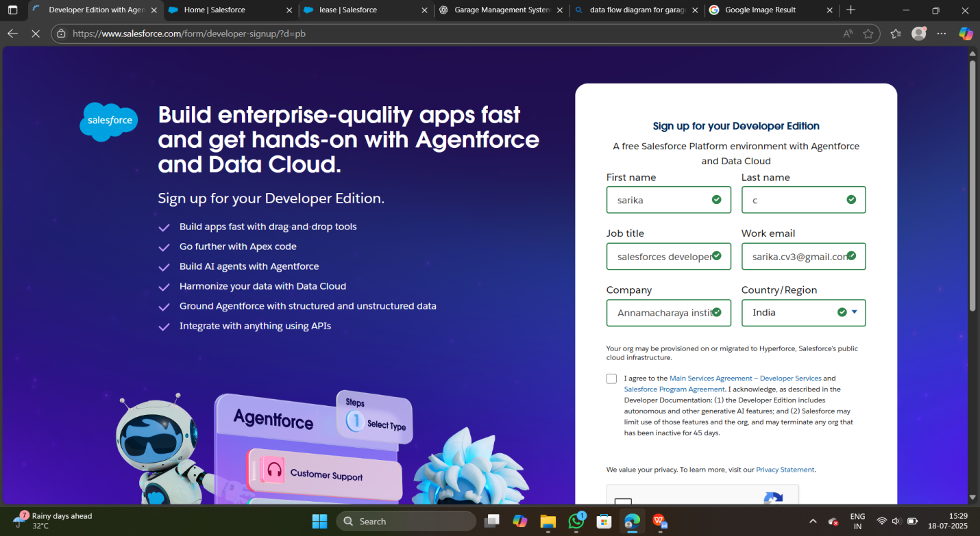
Milestone 2: Object Creation
- Created 3 key custom objects:
Service Booking, Billing, and Mechanic
- Established foundational schema for the Garage Management System to support customer servicing, labor assignment, and billing workflows.
- Configured relationships using lookup fields to connect:
Service Booking → Customer, Vehicle, Mechanic
Billing → Service Booking
Mechanic → Garage Branch

OUTPUT SCREENSHOT

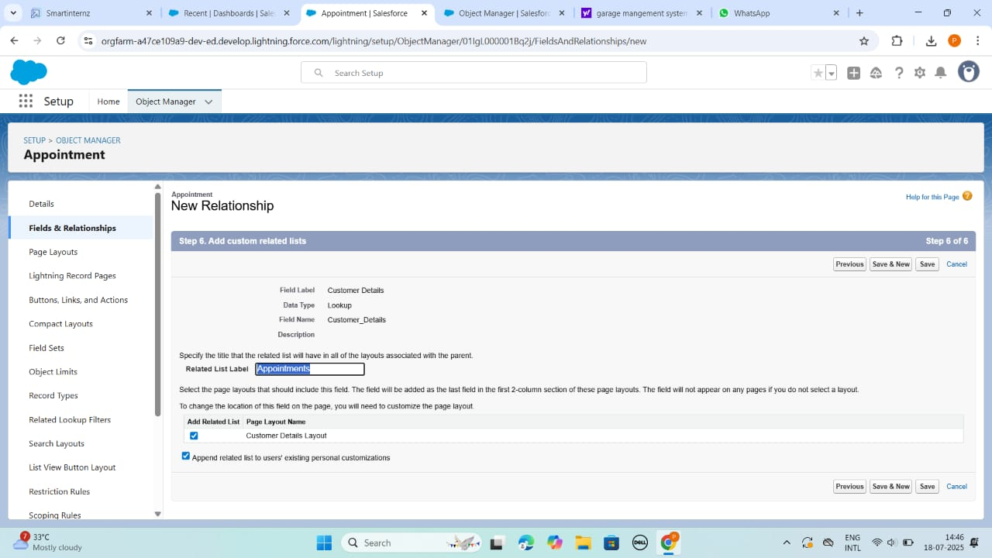

Milestone 3: Tab Creation
- Created tabs for each core custom object:
Customer, Vehicle, Service Booking, Mechanic, Billing, and Spare Parts
- Enabled easy navigation and object access within the Garage Management App using Lightning App Builder
- Ensured users (staff, managers, mechanics) can create, view, and manage records directly from the UI with user-friendly layouts and tab visibility

OUTPUT SCREENSHOT
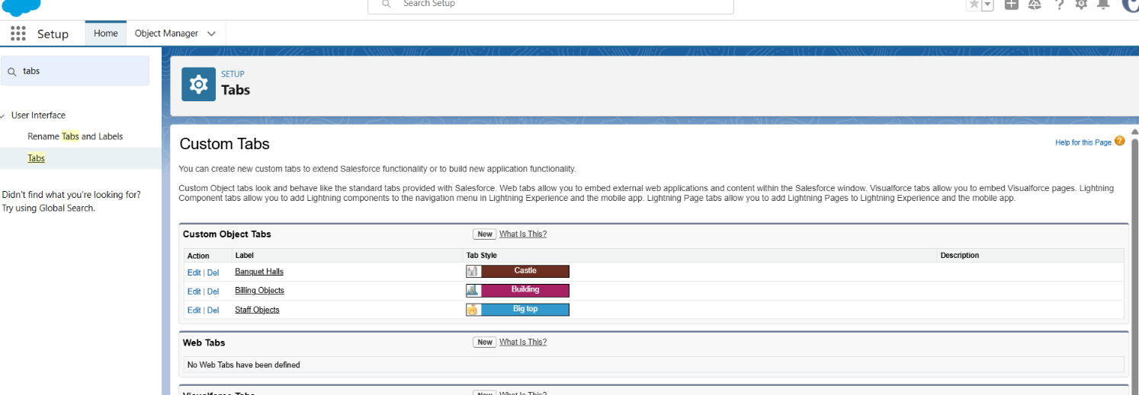
Milestone 4: Lightning App Setup
- Built a custom Lightning App named "Garage Management System"
- Added relevant tabs including:
Customer, Vehicle, Service Booking, Mechanic, Billing, and Spare Parts
- Centralized all garage operations within a single interface for staff, mechanics, and managers
- Simplified user workflow by grouping related features and ensuring intuitive navigation using the Lightning App Builder

OUTPUT SCREENSHOT

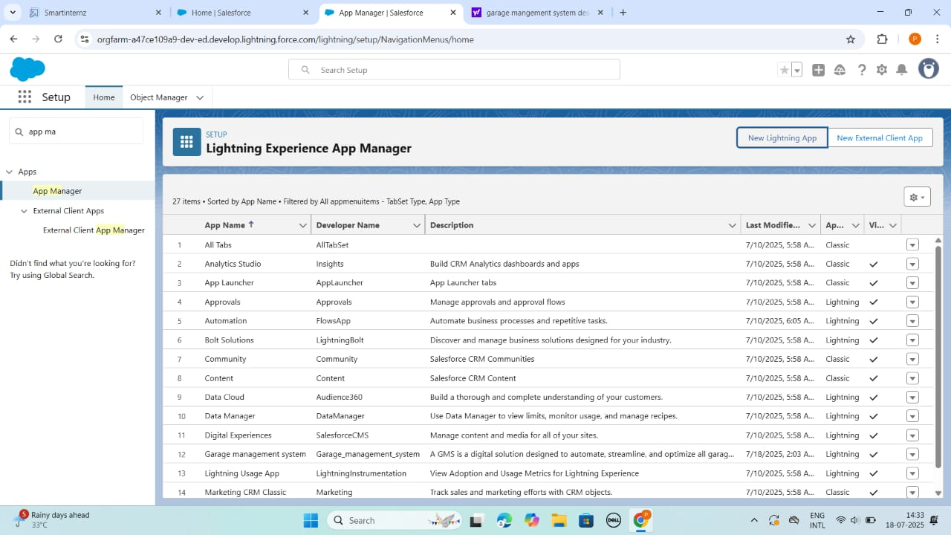

Milestone 5: Field Creation
- Added custom and formula fields across key objects like:
Service Booking, Mechanic, Billing, and Spare Parts
- Example Formula Fields for Cost Calculation:
plaintext
CopyEdit
// Add-on service charges based on customer preferences
IF( Customer__r.Engine_Scan__c = TRUE, 1000, 0 )

IF( Customer__r.Wheel_Alignment__c = TRUE, 1500, 0 )

IF( Customer__r.Car_Wash__c = TRUE, 500, 0 )

IF( Customer__r.Pickup_Service__c = TRUE, 300, 0 )

// Oil service package selection
CASE( Vehicle__r.Oil_Type__c,
'Synthetic', 3000,
'Semi-Synthetic', 2000,
'Mineral', 1200,
0
)

OUTPUT SCREENSHOT

Appointment for Garage Management object;
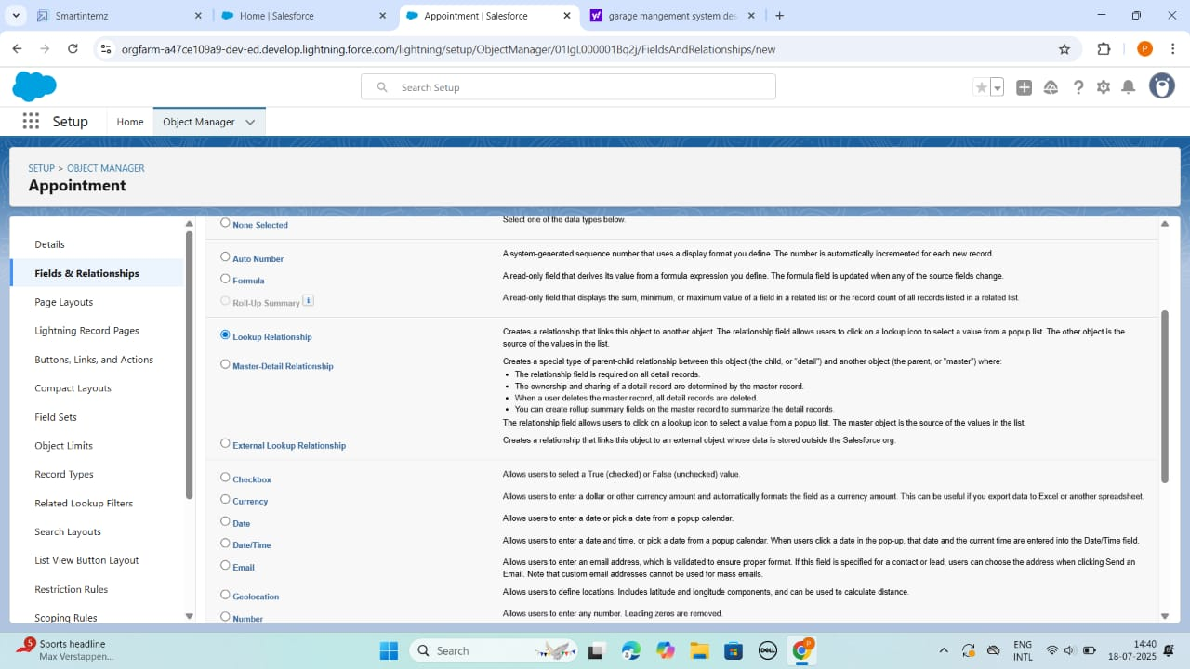

Object Fields

Object Fields
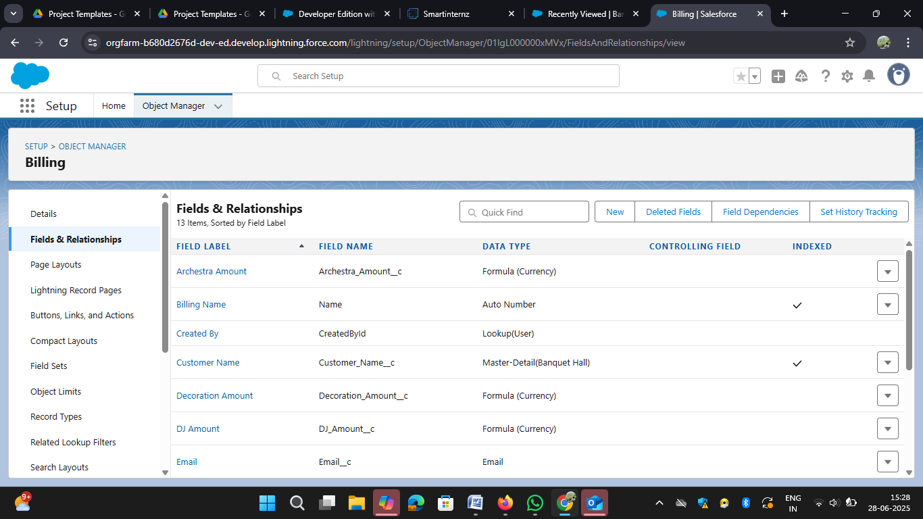

Milestone 6: Validation Rule
- Enforced data quality and consistency across service bookings, billing, and inventory.
- Applied rules to prevent scheduling conflicts, incomplete entries, and invalid formats.
OUTPUT SCREENSHOT
Garage Management object Validation Rules

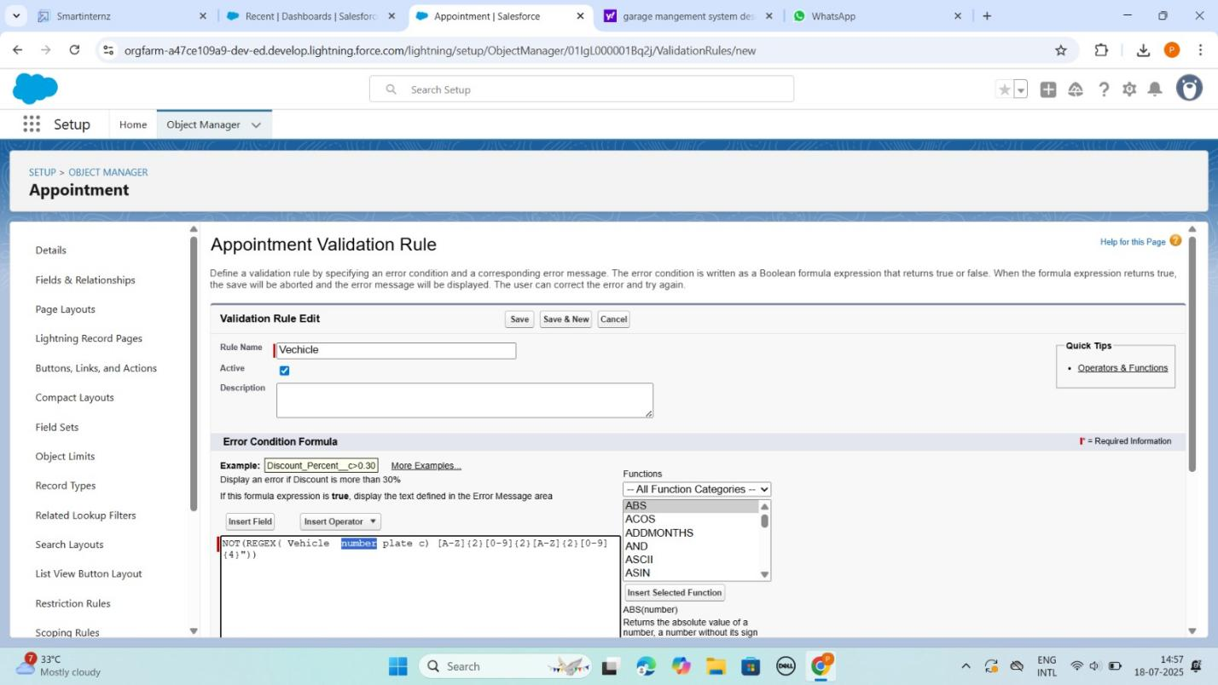

Milestone 7: Duplicate Rule

Type of record is created

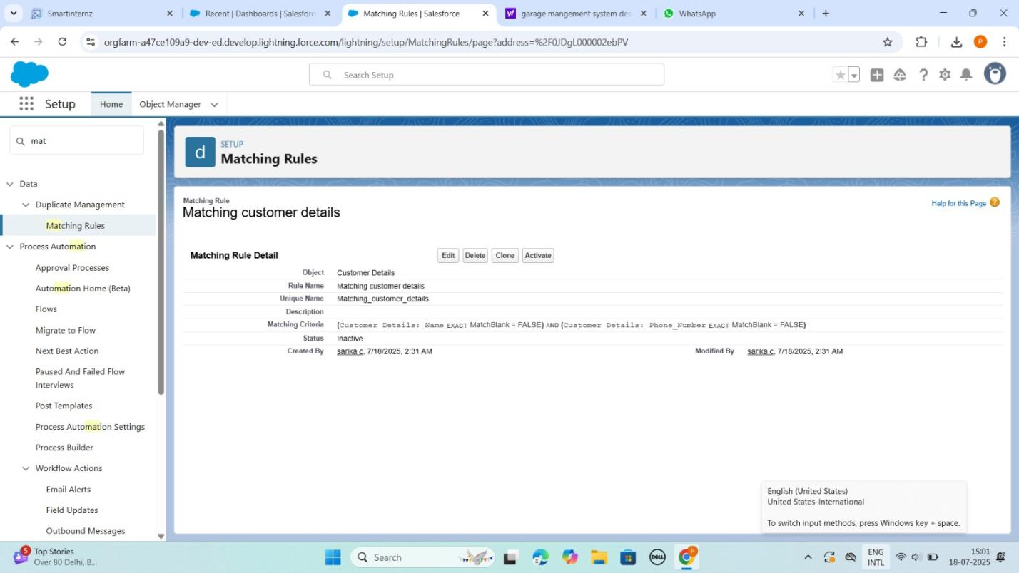

Milestone 8: Profiles
- Garage Manager
- Service Advisor / Receptionist
- Mechanic / Technician

OUTPUT SCREENSHOT

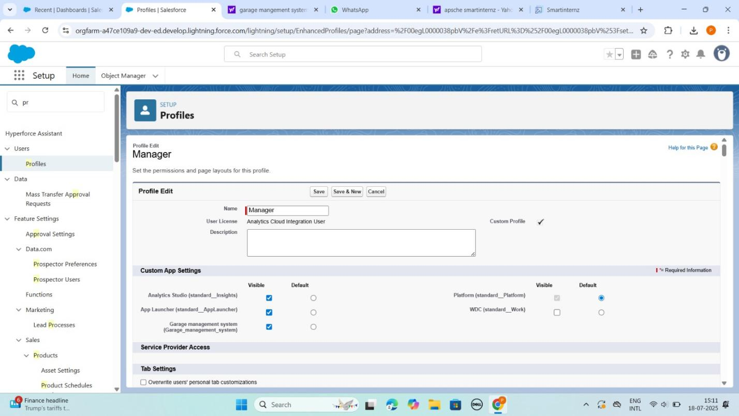
Milestone 9: Role and Role Hierarchy
- Designed a record-triggered flow
- Improved automation and reduced manual input errors

OUTPUT SCREENSHOT

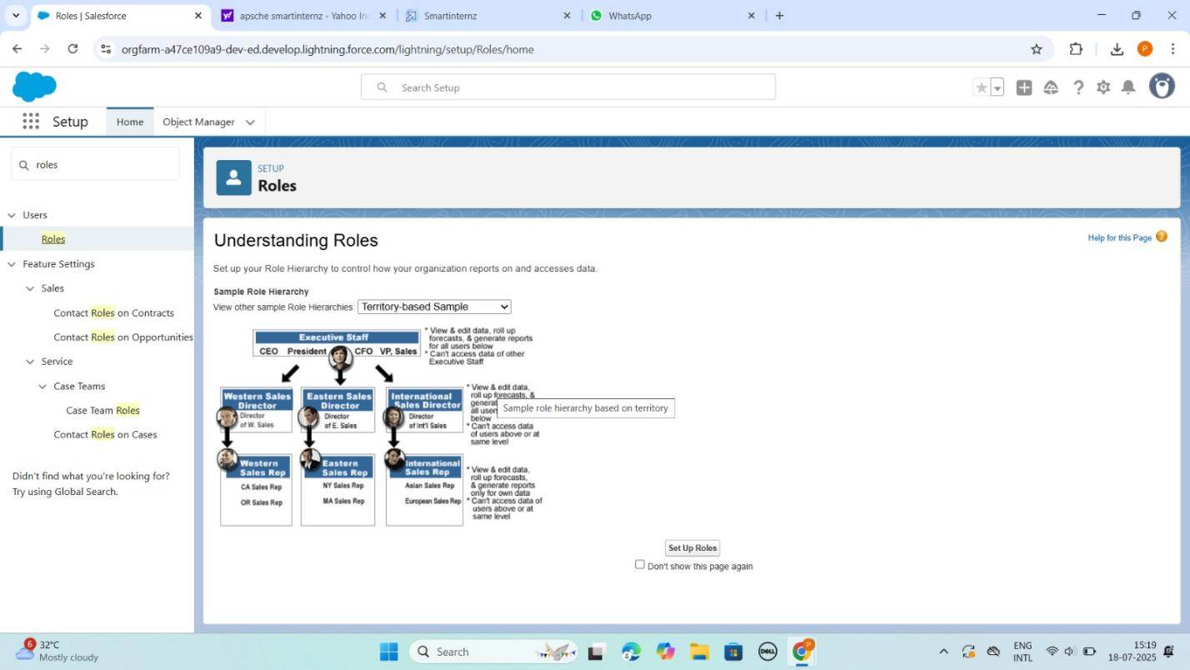

Milestone 10: User
- Developed a trigger to validate:
○ Only users with role “Event Coordinator” can be added as Event Coordinator.
○ Only “Staff” can be added as Staff.
● Ensured business logic is enforced at data level

OUTPUT SCREENSHOT

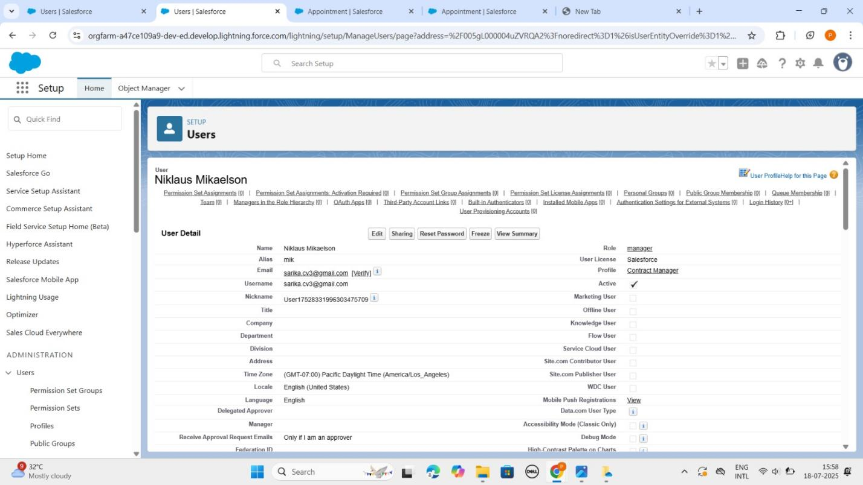

Milestone 11: Public Groups
- Created tabs for each core custom object:
Customer, Vehicle, Service Booking, Mechanic, Billing, and Spare Parts
- Enabled easy navigation and object access within the Garage Management App using Lightning App Builder
- Ensured users (staff, managers, mechanics) can create, view, and manage records directly from the UI with user-friendly layouts and tab visibility

OUTPUT SCREENSHOT

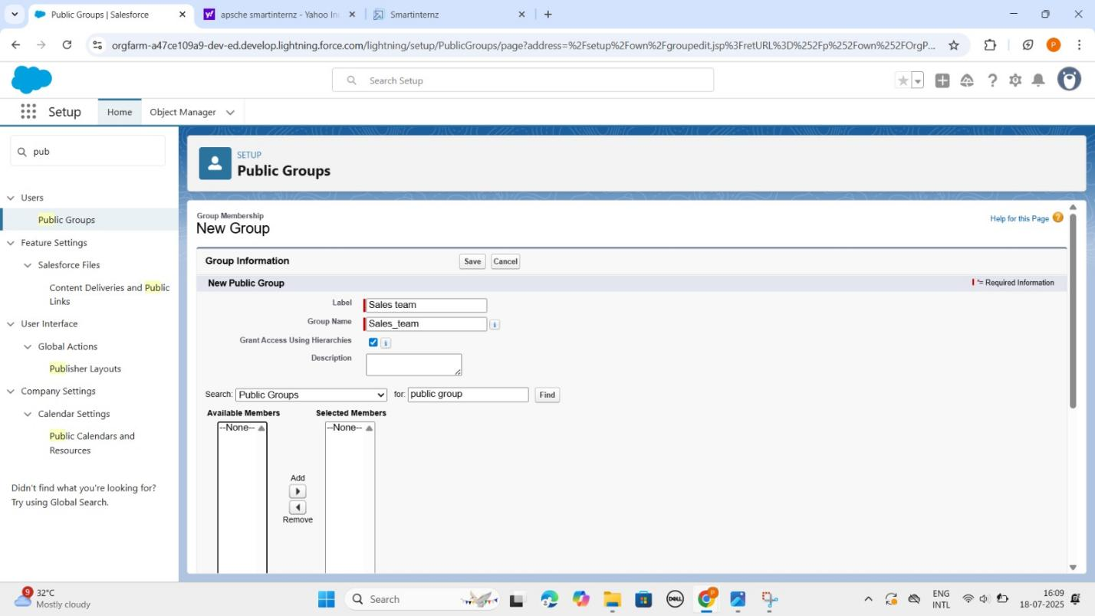

Milestone 12: Sharing and Settings
● Designed dashboards showing:
○ Total Revenue and role summary.
● Used pie, and summary widgets for visualization.

OUTPUT SCREENSHOT

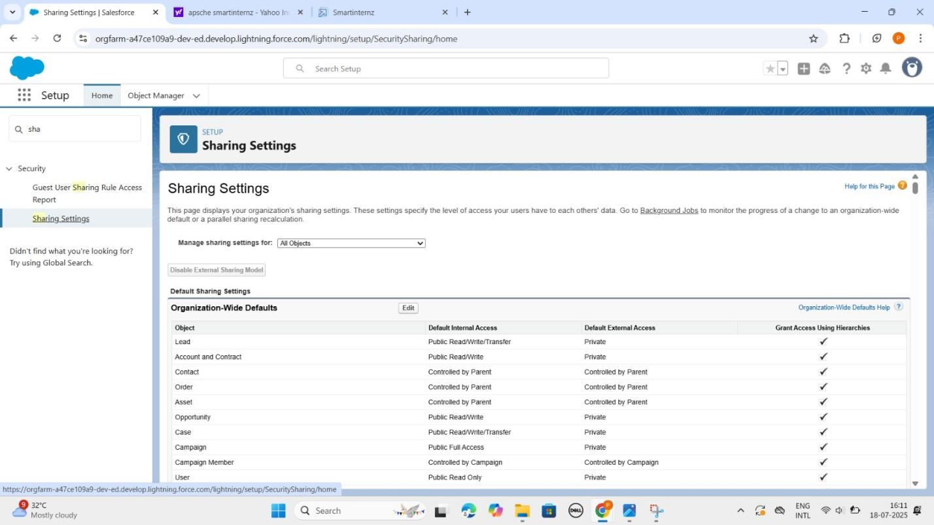

Milestone 12: Flows
- Appointment Booking
- Work Order Generation & Assignment (Autolaunched Flow)
- Inventory Monitoring (Scheduled Flow)

OUTPUT SCREENSHOT

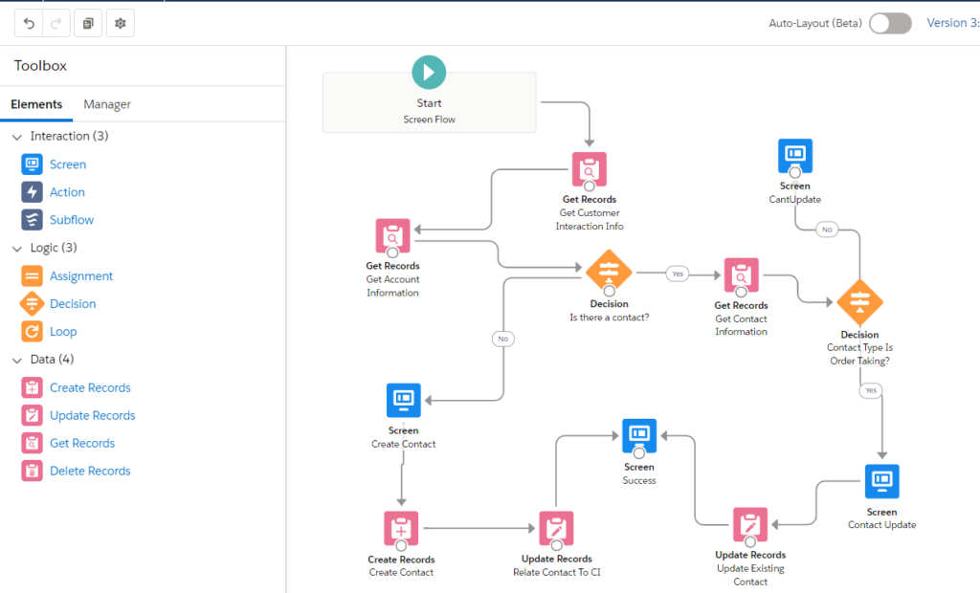

Dataset
The system was tested with the following types of data:(Sample Records and
Input Values Used During Testing)

Milestone 13: Apex trigger
- Handler pattern: keeps your trigger logic clean and scalable by delegating to a separate
- Apex class.
- Extending for Garage Needs.
- Appointment Trigger: auto-create Work_Order__c when a Service_Appointment__c is inserted.

OUTPUT SCREENSHOT

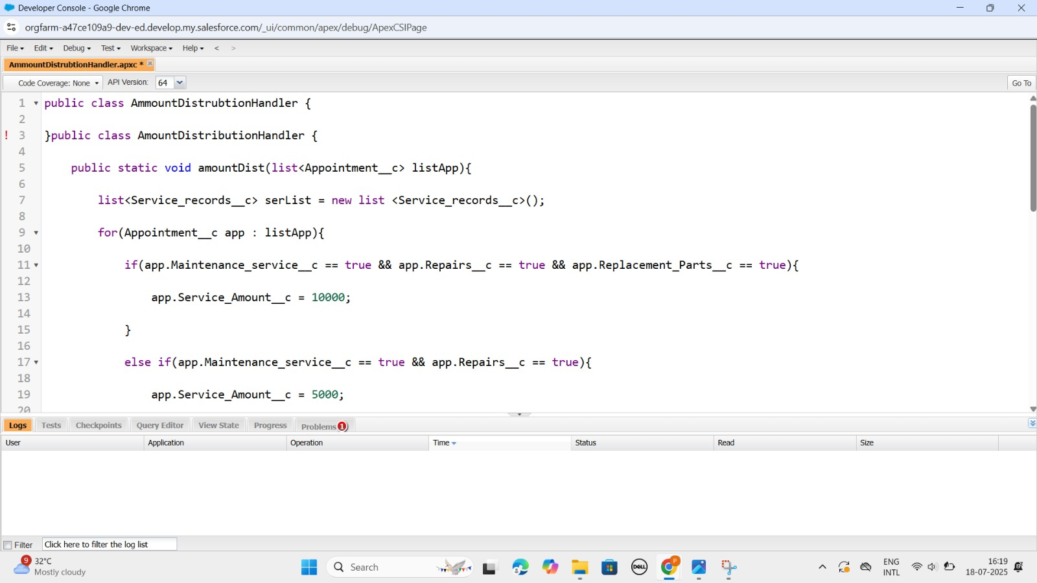

Milestone 14: Reports
- Go to the app >> click on the reports tab.
- Click on the All folder , click on the Drop down arrow for Garage Management folder, and Click on share.
- Select the share with as “roles”, in name field search for “manager”, give “view” as access for that role.
- Then click share, and click on Done.

OUTPUT SCREENSHOT

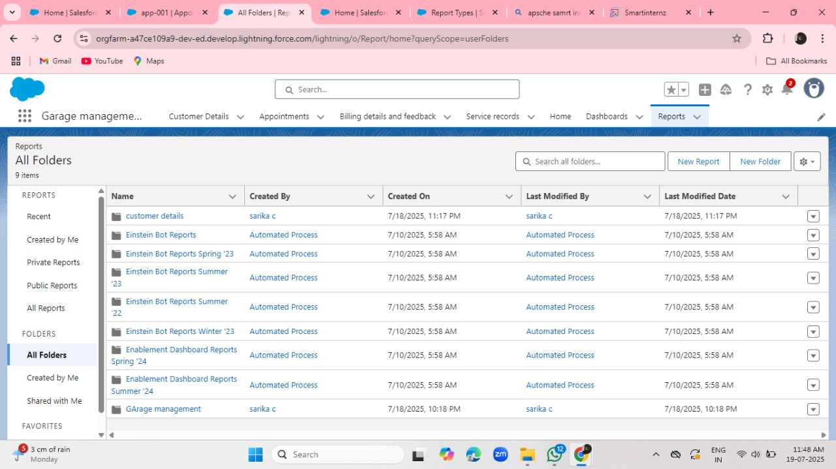

Milestone 15: Dashboard
- Click on the app launcher and search for dashboard.
- Click on dashboard tab.
- Click new folder, give the folder label as “ Service Rating dashboard”.
- Folder unique name will be auto populated.

OUTPUT SCREENSHOT

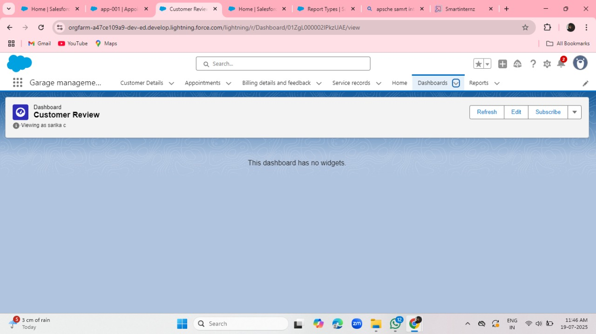

Milestone 16: User Adoption
Creating records
- To create a record in the follow objects follow these steps
- Click on the app launcher located at the left side of the screen.
- Search for “ Garage Management” and click on it.
- Click on the “ Consumer details tab”.
- Click on new and fill the details as shown below figs, and click save.
- Click save.

OUTPUT SCREENSHOT

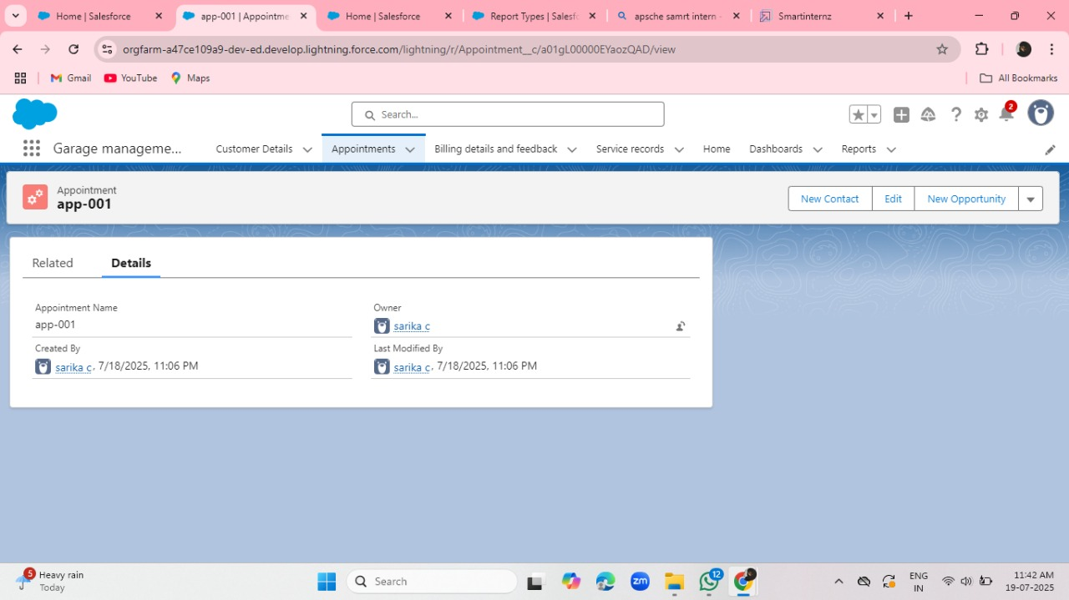

7. FUNCTIONAL AND PERFORMANCE TESTING
7.1 Performance Testing
The system was evaluated using realistic booking scenarios and sample data across venues, customers, and service packages. Key validations performed during the testing phase included:
- Trigger for role validation (Event Coordinator/Support Staff) to ensure only eligible users were assigned specific event responsibilities
- Flow for auto-fetching event cost based on venue, service package, and guest count parameters
- Field validation for input accuracy, such as mobile number formats, event dates, and payment fields
S.No | Parameter | Value/Observation | Screenshot suggestion
1. | Model Summary | Salesforce CRM setup for the Banquet Hall Booking project leverages custom objects, relationships, automation flows, and validation triggers to streamline event operations. All configurations are aligned with the defined schema to support data integrity. Test data import succeeds only if object relationships and formats are accurate.
2. | Field Validations | Tested rules such as:  - Age must be above 21 for staff and customer eligibility  - Phone number must be exactly 10 digits to ensure contact accuracy  - Mandatory fields (e.g., event date, venue, customer name) cannot be left empty  The system successfully blocks incorrect or incomplete entries to uphold data integrity and operational accuracy.
3. | Automation Accuracy(Flow +Trigger) | Flow: Auto-fetch event cost based on venue, vendor package, and duration  Trigger: Validates assigned role is either “Event Coordinator” or “Support Staff”  Test Result: All logic executed successfully in trial runs
4. | Reports Testing | Event Summary Report displays correct grouping by venue and event date  Total cost and guest counts are accurately calculated using formula fields  Report export and download functions tested and confirmed working as expected
5. | Dashboard Verification | Dashboards built using correct source reports from bookings, venues, and payments  Visuals reflect live event data like booking counts, total revenue  Tested filter logic and component refresh for real-time accuracy
6. | Data Accuracy (Manual +Automated) | Manual test records were entered to validate input rules and automation flows  Flow logic was verified for various combinations of venue, vendor packages, and guest count  Output values matched expected results across all test scenarios, confirming accurate system behavior
Summary
All Salesforce components were thoroughly tested for:
● Validation rule enforcement
● Flow and trigger logic correctness
● Dashboard accuracy
● Report reliability
● Data relationships integrity
8. RESULTS
Output Screenshots
Key functional screenshots include;

9. ADVANTAGES & DISADVANTAGES
Advantages
- Real-time data validation and automation reduce manual errors and improve efficiency
- Modular design allows easy customization to fit different garage sizes and workflows
- Centralized system streamlines service booking, mechanic assignment, inventory, and billing processes
- Visual reports and dashboards provide actionable insights for management decisions
Disadvantages
- Requires familiarity with Salesforce for advanced customization and troubleshooting
- Limited offline functionality since it relies on cloud connectivity
- System performance depends heavily on correctly defined object relationships and data integrity
10. CONCLUSION
The project successfully delivered a customized Salesforce CRM application tailored to garage management operations. It streamlined service booking workflows, improved mechanic and inventory coordination, and addressed key operational challenges such as scheduling conflicts and billing accuracy. This initiative provided valuable hands-on experience for the team in both declarative and programmatic Salesforce development, reinforcing best practices in CRM architecture, automation, and scalable system design to support efficient garage operations.

11. FUTURE SCOPE
The Garage Management CRM can be further enhanced with the following advanced capabilities to support scale, mobility, and automation:
- Third-party payment and service integration:
Integrate with payment gateways (e.g., Razorpay, Paytm) for seamless bill settlement and spare parts procurement.
- Automated alerts and communication workflows:
Enable SMS/email notifications for service reminders, billing updates, mechanic assignments, and pickup/drop alerts.
- Mobile-first interface via Salesforce Experience Cloud:
Allow customers to book service slots, track vehicle status, and access service history from their mobile devices.
- AI-powered diagnostics & service forecasting using Salesforce Einstein:
Predict recurring vehicle issues based on historical data, optimize mechanic workload, and forecast spare part demand.
- Customer Loyalty Program Integration:
Introduce reward points and discounts based on service frequency and spend history.
- Inventory Auto-Replenishment Alerts:
Automatically notify when critical spares (like oil filters or brake pads) fall below reorder levels.

